1. Enable CloudTrail monitoring and store the events in s3 and CloudWatch log events.

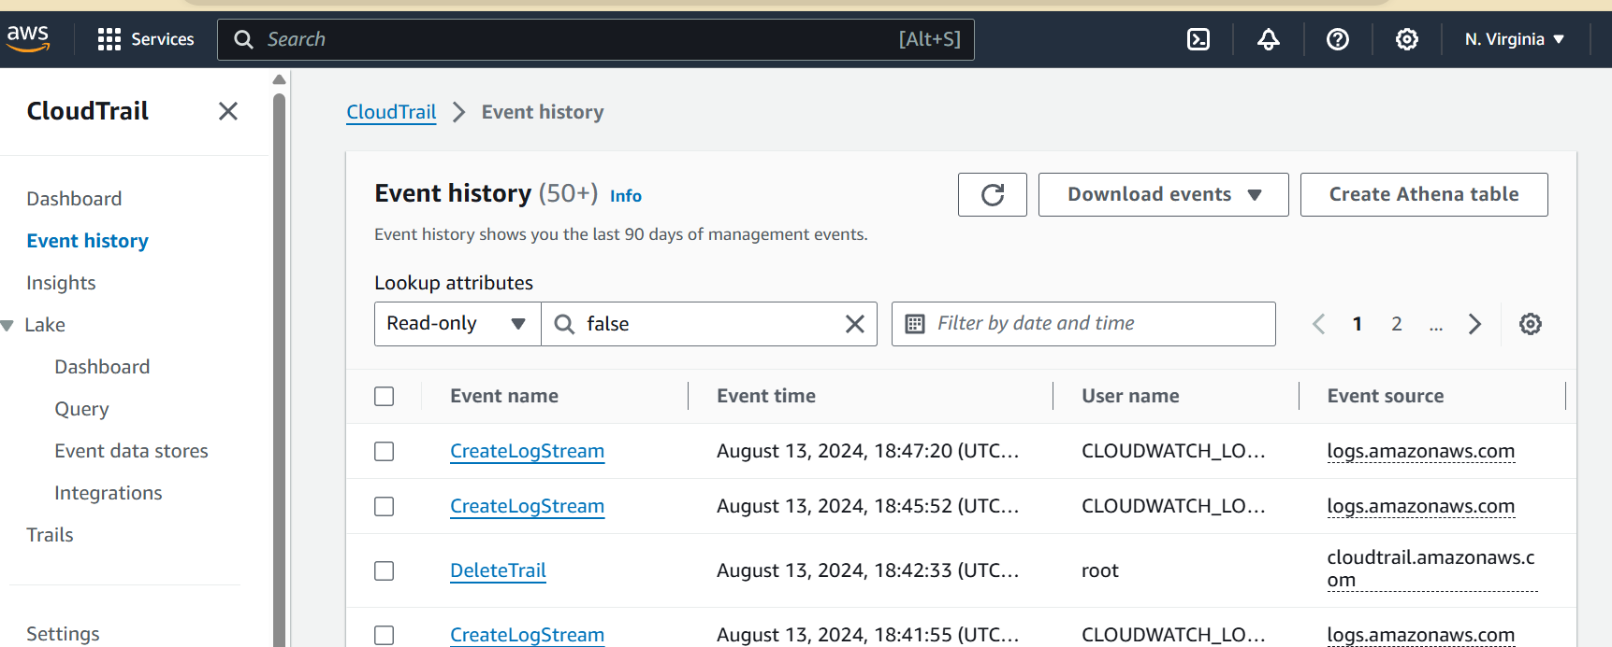

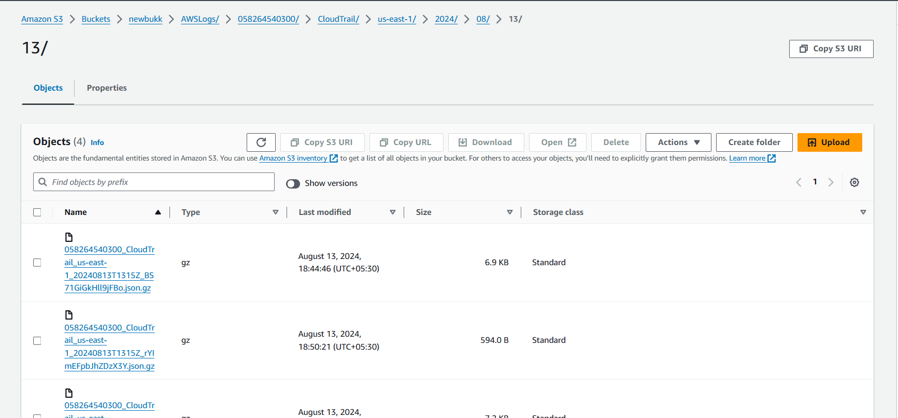

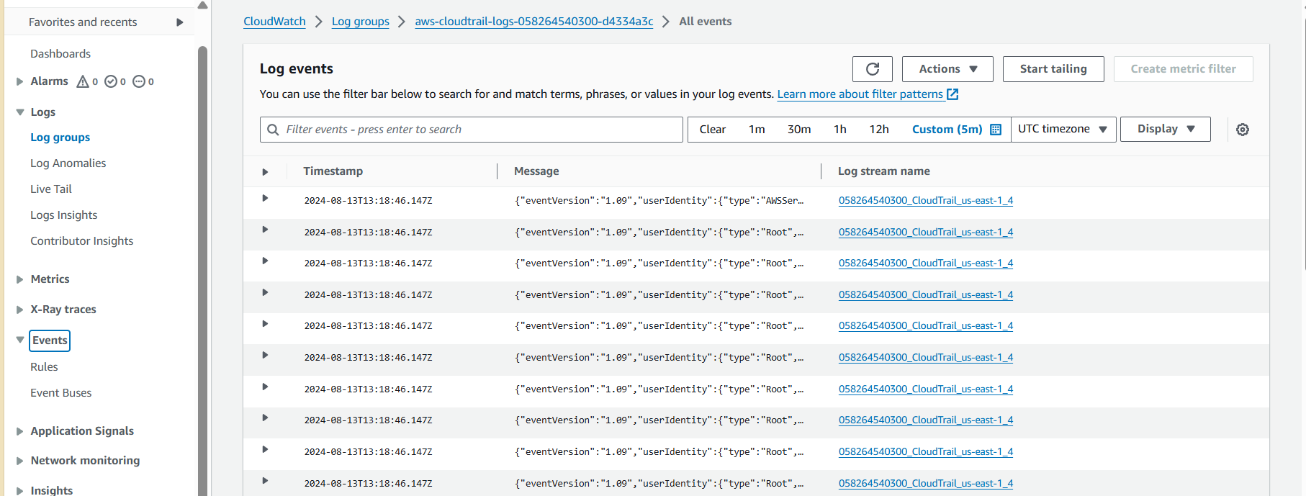

1. Enable SNS for cloud trial to send alert on email.

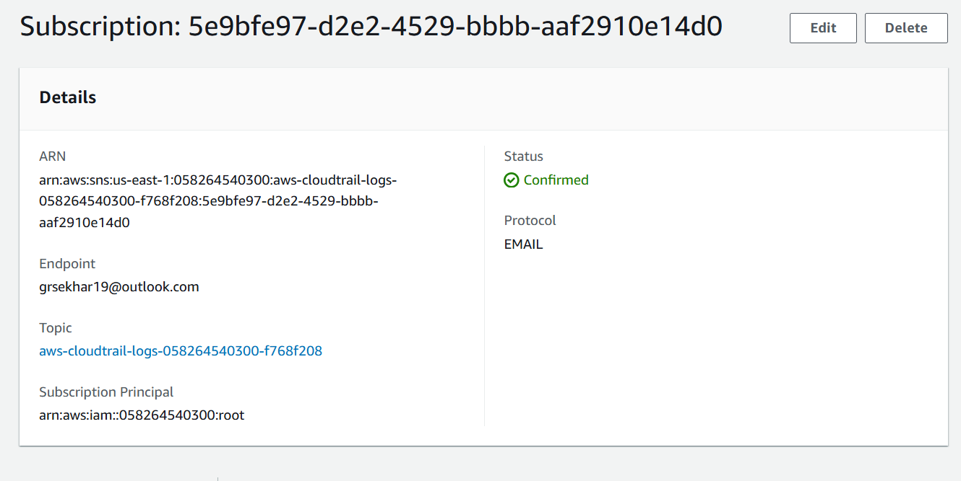

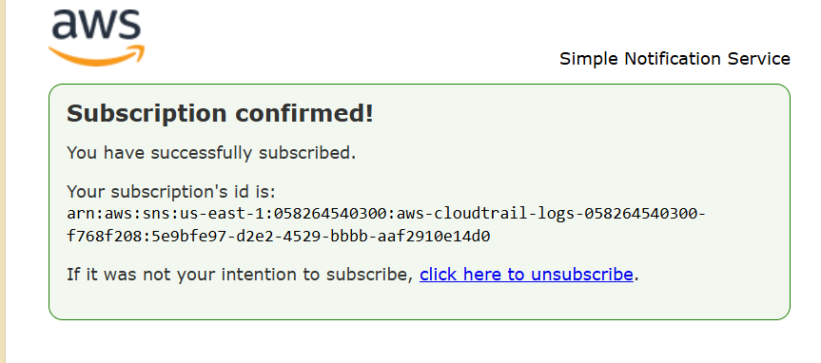

1. Configure cloud watch monitoring and record the CPU utilization and other metrics of ec2.

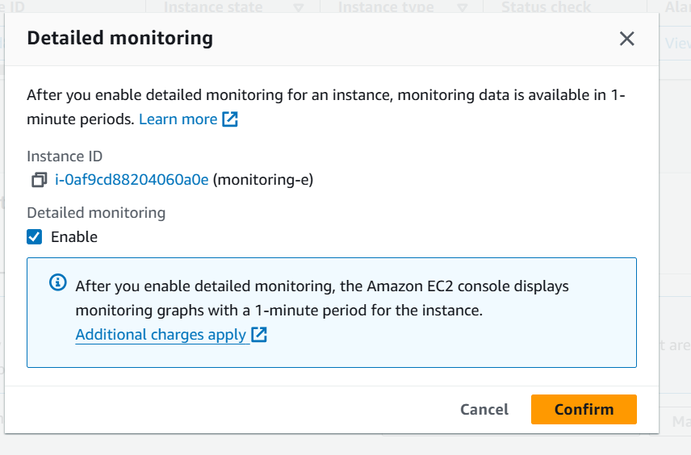

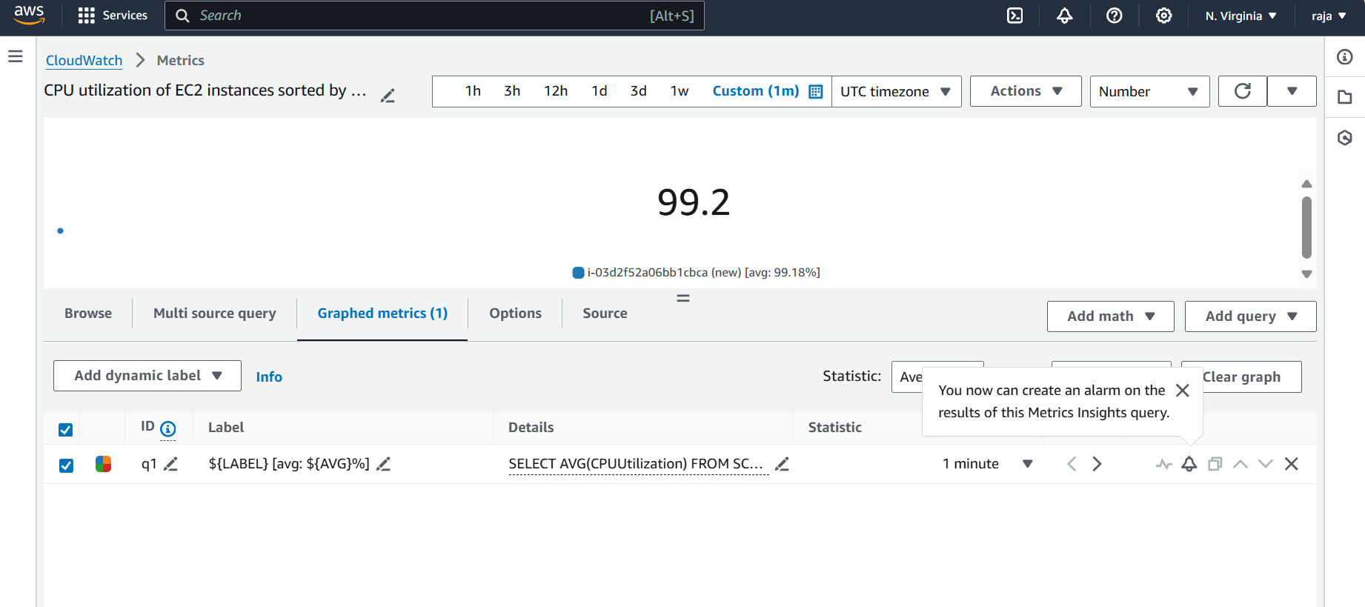

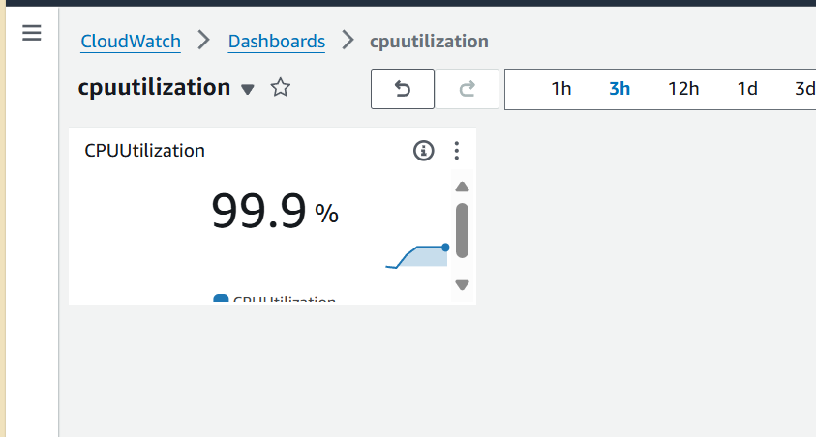

1. Create one alarm to send alert to email if the CPU utilization is more than 70 percent.

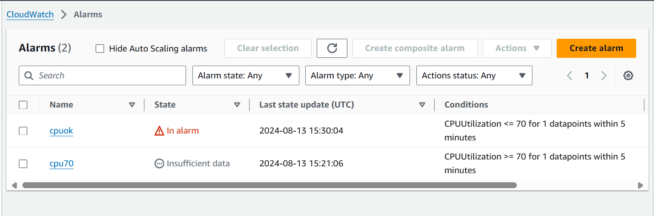

1. Create Dashboard and monitor tomcat service whether it is running or not and send the alert.

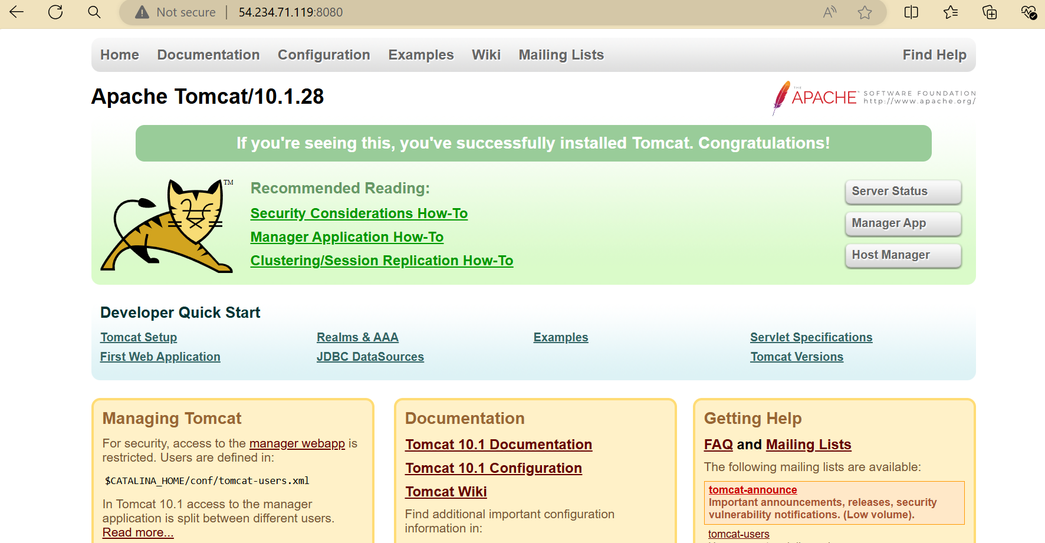

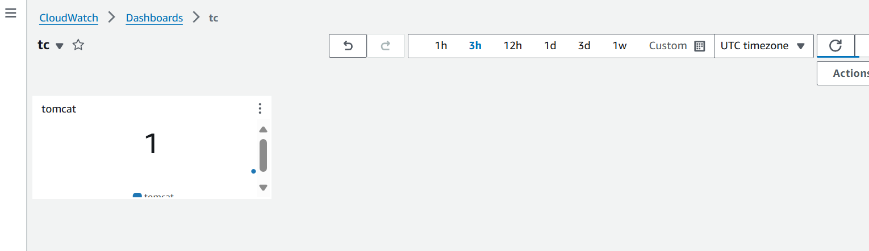

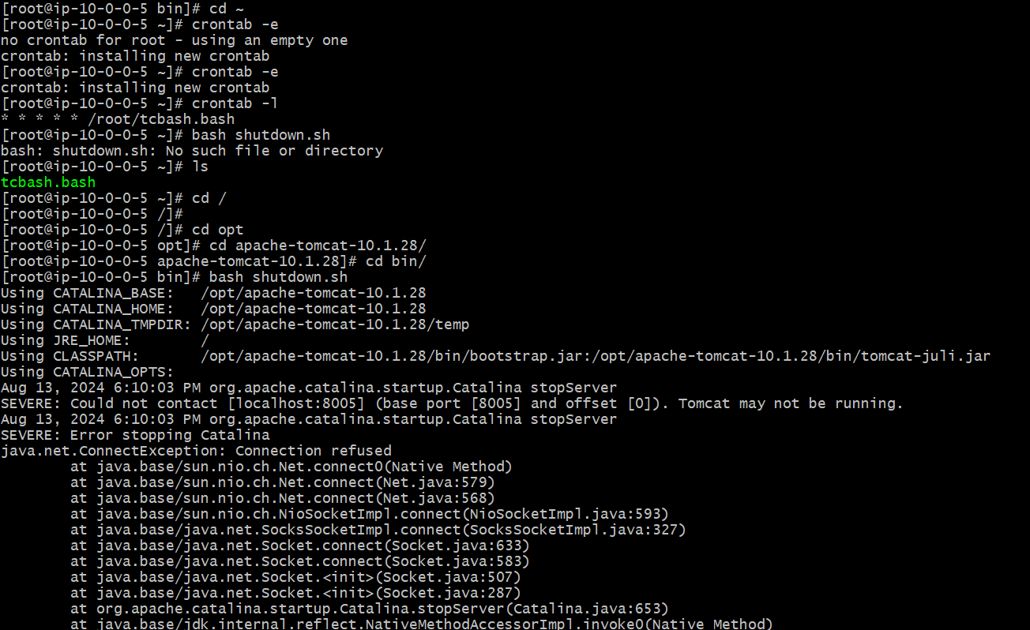



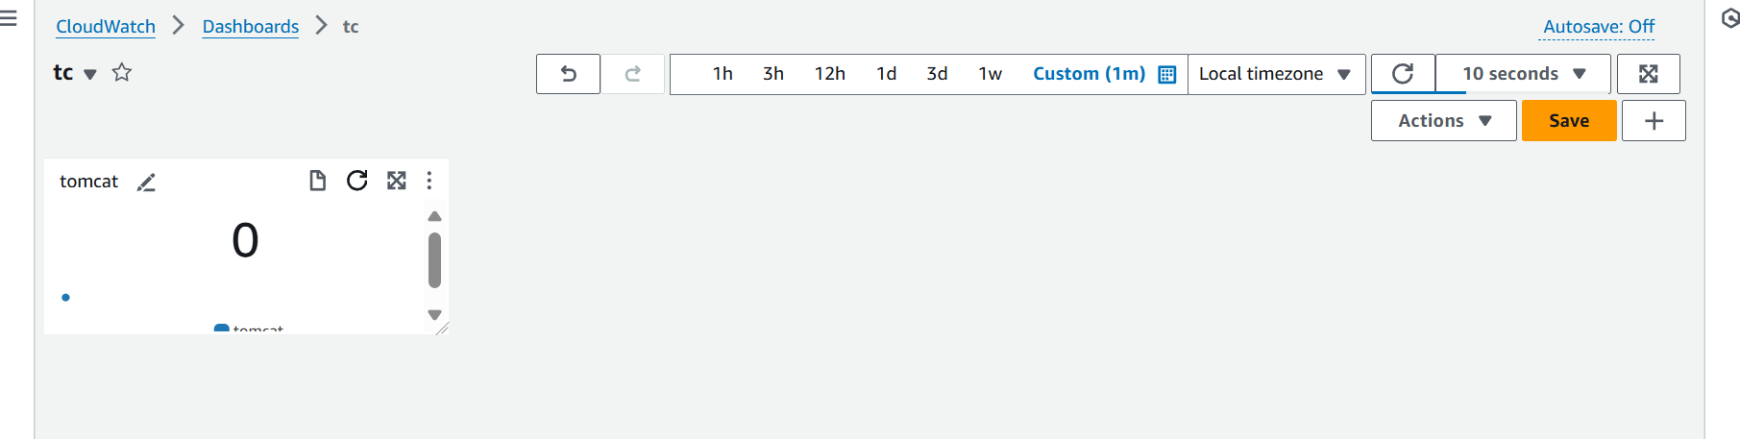

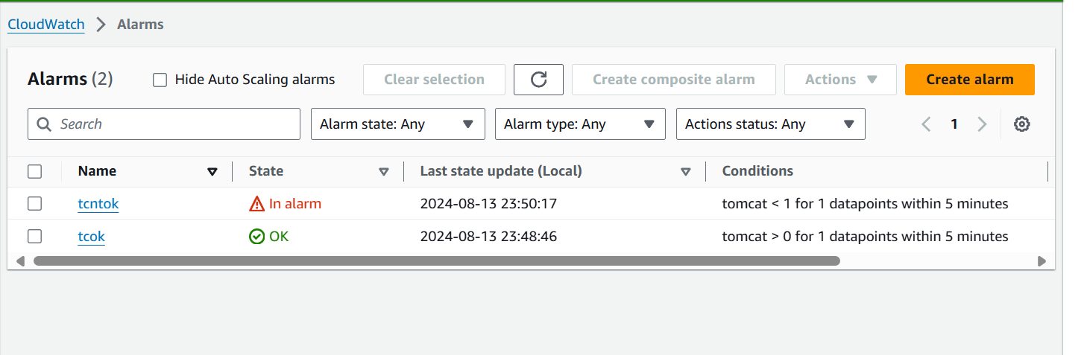

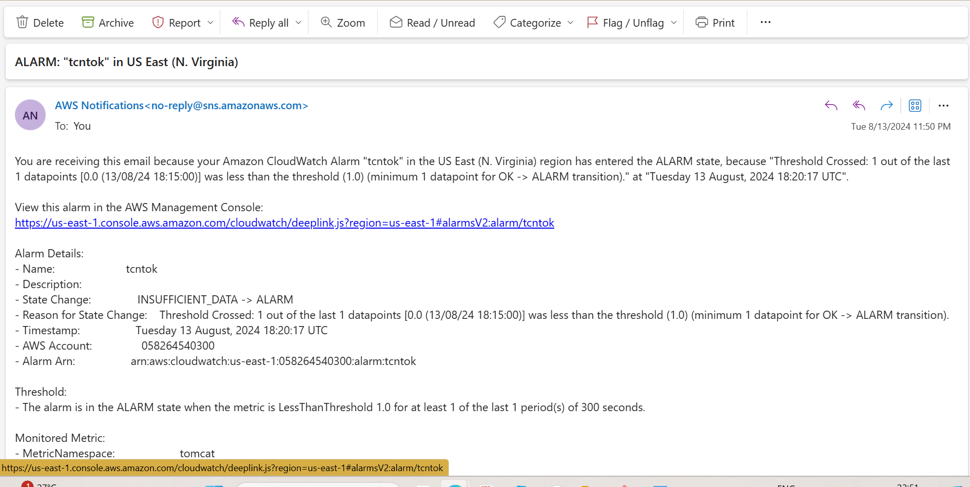

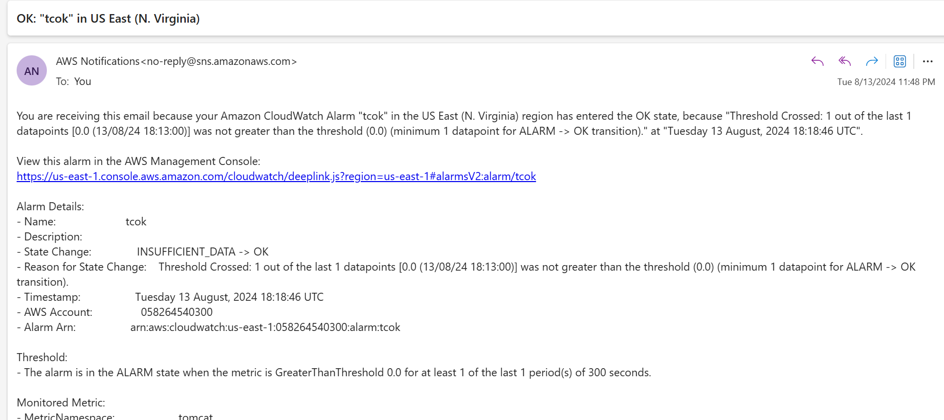

1. Create Dashboard and monitor nginx service to send the alert if nginx is not running.

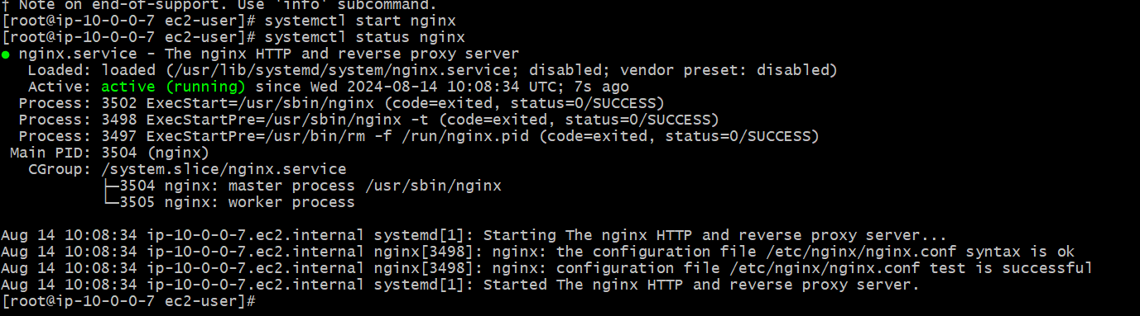

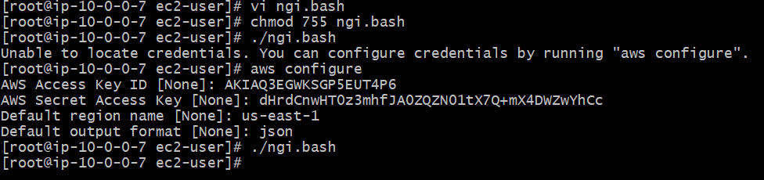

#!/bin/bash# Configuration  
NAMESPACE="Custom/NGINX"  
METRIC_NAME="NginxStatus"  
REGION="us-east-1"  # Change this to your preferred AWS region# AWS CLI command for sending metrics  
AWS_CLI_CMD="aws cloudwatch put-metric-data --namespace $NAMESPACE --metric-name $METRIC_NAME --region $REGION"# Check if NGINX is running  
if pgrep nginx > /dev/null; then  
    STATUS=1  
else  
    STATUS=0  
fi# Send the metric to CloudWatch  
$AWS_CLI_CMD --value $STATUS --unit Count# Logging for debugging  
echo "NginxStatus: $STATUS" >> /var/log/nginx_monitor.log

